Cryptocurrency Calculator



Zachary Merrill

Description:

This project is aimed at creating a cryptocurrency calculator that allows the user to convert, calculate, and analyze the pricing of the world of universal digital currencies. This topic is something that has interested me since I mine cryptocurrency on the side with my brothers. This application is targeted at anyone interested in or using cryptocurrencies. The application will include the following functionalities.

1. Conversions for the most known cryptocurrencies
2. Calculating how much each cryptocurrency is worth in USD
3. The ability to change/update the value of cryptocurrencies to their current value
4. The ability to add a new upcoming cryptocurrency to a pool
5. The ability to remove cryptocurrencies from the pool
6. The ability to view the names, prices, conversions, supply, and ranks of all added to the pool

Specifications:

Tentative Input/Output:

The user will be presented a menu to choose between the functionalities. The user would then input the related variables and the application would print the desired output.

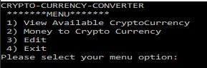

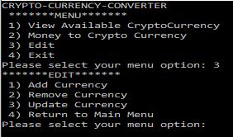

Pseudocode/Flowchart

LOOP FOR MAIN MENU

PROMPT user for menu input

IF menu = 1

VIEW ALL DATA

ELSE IF menu = 2

CONVERSIONS FROM MONEY TO CRYPTO

ELSE IF menu = 3

EDIT MENU

IF selection = 1

ADD FUNCTION

ELSE IF selection = 2

REMOVE FUNCTION

ELSE IF selection = 3

UPDATE FUNCTION

ELSE IF selection = 4

RETURN TO MAIN MENU

ELSE

PRINT ERROR

ELSE If menu = 4

END LOOP

ELSE

PRINT ERROR

Convert Function

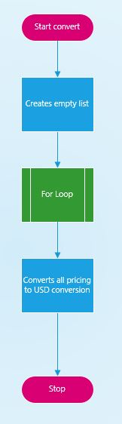

addCurrency Function

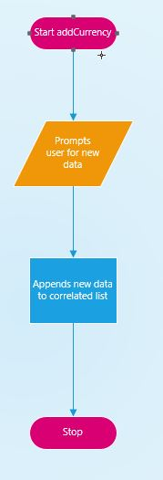

viewAvailableCurrency Function

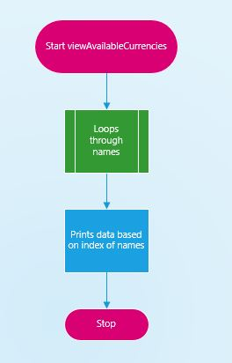

removeCurrency

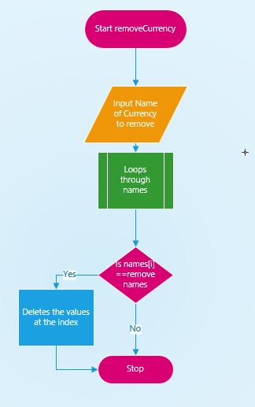

updateCurrency

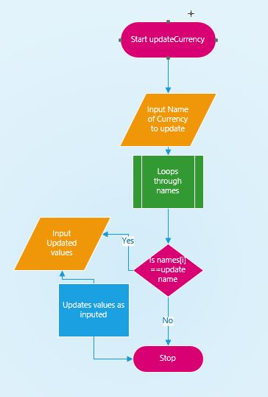

moneyToCurrency

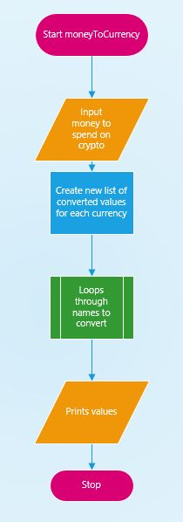

Main

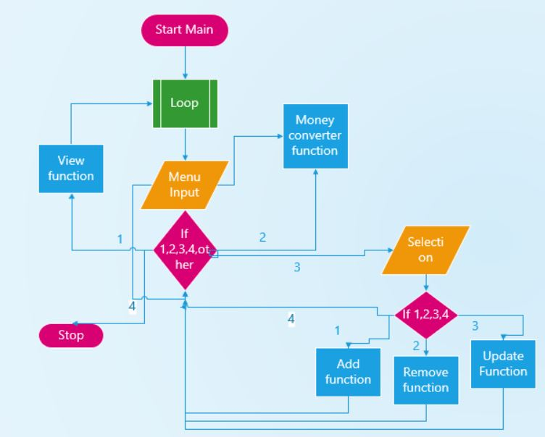

Error Handling  
  
  
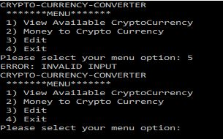

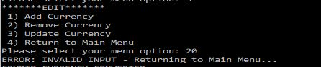

Conversions Referenced from current crypto pricings from:  
<https://coinranking.com/>